**Chapter 1: MODERN PHYSICS**

* 1. **Introduction about quantum Mechanics**

Quantum mechanics is a new branch of study in physics which is indispensable in understanding the mechanics of particles in the atomic and sub-atomic scale. The motion of macro particles can be observed either directly or through microscope. Classical mechanics can be applied to explain their motion. But classical mechanics failed to explain the motion of micro particles like electrons, protons etc...

Max Plank proposed the Quantum theory to explain Blackbody radiation. Einstein applied it to explain the Photo Electric Effect. In the meantime, Einstein’s mass – energy relationship () had been verified in which the radiation and mass were mutually convertible. Louis de-Broglie extended the idea of dual nature of radiation to matter, when he proposed that matter possesses wave as well as particle characteristics.

The classical mechanics and the quantum mechanics have fundamentally different approaches to solve problems. In the case of classical mechanics it is unconditionally accepted that position, mass, velocity, acceleration etc. of a particle can be measured accurately, which, of course, true in day to day observations. In contrast, the structure of quantum mechanics is built upon the foundation of principles which are purely probabilistic in nature. As per the fundamental assumption of quantum mechanics, it is impossible to measure simultaneously the position and momentum of a particle, whereas in the case of classical mechanics, there is nothing which contradicts the measurements of both of them accurately

* 1. **Failure of Classical Physics**

Classical Mechanics describes the motion of macroscopic objects. It provides extremely accurate results as long as the domain of the study is restricted to large objects and the speed involved does not approach the speed of light. This unexplainable behavior at microscopic level gave birth to Quantum Mechanics or it was called as Failure of Classical Physics which could not explain the behavior of element/ matter at microscopic level.

There are three failures of Classical Physics

1. Black Body Radiation
2. Structure of an Atom
3. Photoelectric effect
4. **Black Body Radiation**

In 1897, Lummer and Pringshem measured the intensities of different wavelength of blackbody or Cavity radiations. At different temperatures, body radiates different electromagnetic radiation at different intensities and wavelength. At Room temperature, most of the radiation is in Infrared region, hence it is invisible

The ability of the body to radiate is closely related to ability to absorb the radiation. Since a body at constant temperature is in thermal equilibrium with its surrounding and must absorb energy from them at the same rate as it emits energy. Thus an ideal body one that absorbs all radiation incident upon it regardless of frequency such a body is called a black body.

Light entering the cavity is trapped inside by the multiple reflection from the walls. When heated the black body would emit more from a unit area than any other body at a given temperature.

A spherical cavity blackened inside and completely closed except a narrow aperture serves as an ideal black body.



Fig.1.1 Spherical Cavity

Anybody at any temperature above absolute zero will radiate to some extent, the intensity and frequency distribution of the radiation depending on the detailed structure of the body. The simplest possible case is an idealized body which is a perfect absorber, and therefore also (from the above argument) a perfect emitter. For obvious reasons, this is called a “black body”.

The energy was distributed in the different wavelength in the spectrum of a black body radiation which can be shown as the figure below.

Fig.1.2 Spectral Energy Distribution of a Blackbody



Initial effect was made by Stefan-Boltzmann law that the energy of radiation emitted from a black body at a temperature T is due to all wavelengths in a spectrum is directly proportional to the 4th power of the absolute temperature of the body.

i.e,

= Stefan’s Constant =

Now from the spectral distribution true following points are consider it

1. At given temperature energy is not distributed uniformly throughout the spectrum.
2. At given temperature intensity of the radiation increases with increase in wavelength till it reaches its maximum, then intensity reduces with increasing in wavelength
3. With increasing temperature the wavelength decreases

Wien’s displacement law states that the peak of wavelength, at which the maximum emission occurs for any given temperature, is inversely proportional to the absolute temperature of body.

The above equation is called as the Wien’s Displacement Law

1. The area under the curve gives the total energy emitted at given temperature.
2. **Rayleigh-Jeans explanation and Planck’s proposition:**

According to the distribution of energy in spectrum was given by

Where

Random thermal motion of atoms within the walls generates EM waves, which is the thermal radiation emitted from the wall cavity. The radiation emitted by the atoms is reflected back and 4th in cavity to form a system of standing waves for each frequency.

Finally, when thermal quality is attained the average rate of emission of radiant energy atomic oscillation is equal to the rate of absorption of radiant energy by walls.

Equation is called as Rayleigh-Jeans law i.e.

Now, this energy was calculated for a long wavelength. In the energy spectrum graph, the formula agreed for long wavelength and but goes towards Infinity at the shorter wavelength end. This contradiction came to the note as ultraviolet catastrophe.

The failure of Rayleigh-Jeans formula gave the first indication of inadequacy of classical physics

1. **Planck’s radiation law or Planck’ proposition**

In 1900 **Planck** recognized the reason for ultraviolet catastrophe was that Rayleigh assumed the standing waves in cavity of body consist of fundamental modes of vibration. Each having energy, thus making the total energy of the cavity Infinity.

Plank’s suggested that an oscillating atom can only absorb or remit energy only in quantities that are integral multiple of

This district energy is called energy quantum,

In general,

Where

Using a Maxwell Boltzmann distribution law, Plank’s obtained the energy density in black body radiation as

This Equation is Planck’s radiation law.

Planck’s hypothesis of discrete quanta of energy was the origin of quantum physics and the investigations on the continuous spectrum emitted by black body was the birth of Quantum physics.

* 1. **Wave Particle Duality**

According to the de-Broglie the photos of light having frequency and has a momentum as

Therefore its wavelength can be given as,

Now the momentum of photon is given by,

We know that, in a vacuum the frequency is given by,

Substituting equation in equation

Also, for a photon, we know that

Equation and represents general de-Broglie equation that can be applied for particles and waves.

In some cases, momentum is given as where which is given by

**1.3.1 Compton Effect:**

Compton Effect gives direct and conclusive evidence in support of the particle nature of electromagnetic radiation. Compton explained this effect by treating X-rays as a stream of photos (or particles which scattered after the collision of electrons)

When a monochromatic beam of X-rays (or the electromagnetic radiation of short wavelengths) of wavelength allowed to incident on scattering materials, the scattered beam contains radiation of longer wavelength in addition to the radiations of incident wavelength. The difference between and i.e., is known as Compton shift and the effect is called as a **Compton Effect.**

The Compton shift does not depend on the wavelength of incident radiation and nature of scattering materials. It depends on the scattering angle only.

**Derivation for Compton Shift:**



Now, before deriving the equation for Compton shift we should know certain basic equations.

i.e., the energy of a photon is given by and the energy of a particle is given by where

The Energy mass relativistic equation is,

Using the above equations, we can derive the Compton Shift equation.

Now, Let us consider the conservation of momentum of particles after collision for vertical and horizontal site.

For Horizontal momentum,

For Vertical momentum,

Using, to combine equation and

Also, Conservation of Energy is given as,

Using for electron (particle) and for photon (incident and scattered)

Note: For before collision, the particle is at rest. Hence the momentum = 0.

Substituting equation in equation,

Dividing equation by gives,

We know that, and

Thus substituting and in above equation.

The above equation is called as the Compton Shift in Electron’s wavelength.

**Importance of Compton Effect:**

Compton Effect is an important milestone in development of modern physics Compton Effect proves the following

1. It proves the particle nature of the Electromagnetic radiation
2. This verifies the Planck’s Quantum hypothesis
3. It provides indirect verification of the relation, and as these relations can be used in delivering the expression for Compton Effect.

* 1. **Pair production and Pair Annihilation**

We have seen that in a collision, a photon can give an electron all of its energy (the photoelectric effect) only a (part the Compton Effect). It is also possible for photon to materialize into an electron into an electron and positron which is positively charged electron. In this process pair production, electromagnetic energy converted into matter

No conversation principals are violated when an electron- positron pair is created near atomic nucleus.

The sum of the charge electron and the positronis zero as is the charge of photon,

∴The total energy including rest energy of electron and positron equals a photon energy.

The rest energy of an electron or positron is 0.51 MeV; hence the pair production requires at least energy 1.02 MeV energy of photon .Any additional photon energy becomes a kinetic energy of electron and positron

Maximum photon wavelength is 1.2 pm. EM waves with such a wavelength gamma rays

Also, linear momentum is conserved

Also, if the inverse of pair Production occurs i.e., when a particle and its antiparticle collide, under the influence of the opposing electric charges. The total of energy of two particles appearing as Electromagnetic radiation

The lost mass becomes a forms two gamma ray photon.

OR

This inverse process to pair production is called Pair annihilation

* 1. **Heisenberg Uncertainty Principle**

Due to the dual nature of matter, it is a very difficult to locate the exact position and momentum of the particle simultaneously. This uncertainty was explained by Warner Heisenberg in 1927 through based on certainty principle.

The Heisenberg uncertainty principal states it is not possible to simultaneously measure the position and movement of the particles to any desired accuracy

The product of uncertainty is the measurement of the position ∆x and uncertainty in measurement of momentum ∆p is always constant and it is at least equal to plank’s constant.

But experimentally it is being proved that,

If the uncertainty in measurement of position increases the uncertainty in measurement of momentum decrease and vice versa.

Also, we can write,

and

Where determine energy &time respectively and are uncertainties in measurement of angular momentum and angle respectively.

* 1. **Schrodinger Wave Equation**

The de-Broglie hypothesis states that a wave is associated with material during its motion. It should be very clear that what type of wave is associated with the motion of the particle and what type of mechanics is required for the formulation for such waves.

Schrodinger worked extensively on wave mechanics, used to deal with the matter wave. They gave two very important equations for motion of matter waves.

1. Time independent Schrodinger equation
2. Time dependent Schrodinger equation

***Time independent Schrodinger equation***

We know from matter waves that a material particle is equal to or equivalent to a wave packet.

Now, be the wave displacement for the matter wave at any time t. is the wave function, which is the finite, single valued and periodic function

This wave function is represented as,

Also, we know the total energy of system

)

Now in our wave function

K= wave vector = and ω= angular velocity

Differentiating equation (2) with respect to x

Again differentiating above equation with respect to

Now, and

Substituting above value of key in equation (3)

Now from equation (1) is

Operating both side with

Substituting equation (4) in above equation

This above equation is called **Time Independent Schrodinger Equation** for one dimension

For 3D, **Time Independent Schrodinger Equation** is given as,

Where,

**Time Dependent Schrodinger Equation**

The Time Dependent Schrodinger Equation can be obtained by eliminating E from Time Independent Schrodinger Equation

The wave function for particle is given as,

Now, for particle

The Energy of a wave particle is given as while the momentum of the particle is given as . These are the desired relation.

Differentiating equation with respect to t,

Also from equation (2) , operating on both sides

Schrodinger’s equation is given as

Substituting equation (3) in above equation

This equation (4) is called **Time Dependent Schrodinger Equation** for one dimension

For 3D

In above equation iscalled **Hamiltonian Operator (H)** denoted by whereas

Which operates on is called **Energy Operator (E)**

Thus we can write equation as,

**Momentum operator**

We know,

We know,

The above equation represents momentum operator which operates on for 1D.

For 3D, momentum operator is given by

* 1. **Physical Significance of Wave Function**
     1. **Wave Function**

From the analysis of electromagnetic waves, sound waves and other such waves, it has been observed that the waves are h characterise by certain define properties.

In case of electromagnetic waves, electric and magnetic field vary periodically. In a similar way, the matter a wave varies in a quantity called wave function denoted by.

Schrodinger distributed amplitude of matter waves in terms of wave function. This wave function is a quantity which gives the idea of probability of finding the particle in a particular region of space.

The wave function gives the complete knowledge of behaviour of particle and gives the stationary state which is independent of time.

* + 1. **Well behaved functions**

Wave functions with all these properties can yield physically meaningful results when used in calculations, so only such well-behaved wave functions are admissible as the mathematical representation of real bodies to summarise

1. Must be continuous and single valued everywhere.
2. must be continuous and single valued everywhere
3. Must be normalised which means that must go to 0 as , in order that overall space be a finite constant.

**1.7.3 Normalisation**

It is usually convenient to have be equal to the probability density of finding the particle described byrather than merely be proportional to

If

Then,

A wave function which obeys equation (1) is said to be normalised.

Where probability density

This is given as

The equation becomes

Where is the wave function and is the complex conjugate of that wavefunction.

Note: the probability that the electron or a particle located somewhere must be unity i.e.

Equation shows the probability of finding any particle between and in nth state.

**1.7.4 Eigen values and Eigen functions**

The Schrodinger equations may have many solutions out of these solutions; some are imaginary, which have no significance.

The solutions which have significance for certain value called the eigenvalues. In an atom, eigenvalues correspond to the energy values associated with different orbitals of atom.

The solution of the wave equation for this definite value of E gives the corresponding value of wave function known as Eigen functions.

Only these Eigen functions have a physical significance which satisfies certain conditions

1. They must be single valued function
2. They should be finite
3. They should be continuous throughout the entire space under consideration.
   1. **Particle in One Dimensional Potential Box**

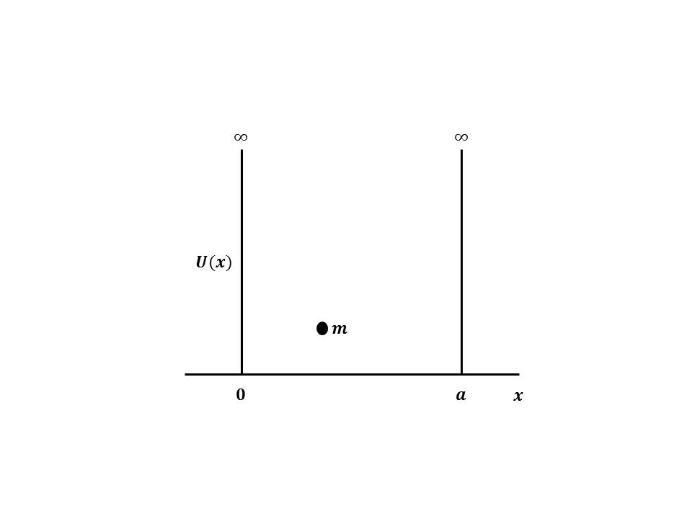

Consider a particle of mass ‘m’ placed inside a one-dimensional box of infinite height and width L.

Assume that the particle is freely moving inside the box. The motion of the particle is restricted by the walls of the box. The particle is bouncing back and forth between the walls of the box at and. For a freely moving particle at the bottom of the potential well, the potential energy is very low. Since the potential energy is very low, moving particle energy is assumed to be zero between and.

The potential energy of the particle outside the walls is infinite due to the infinite P.E outside the potential well.

The particle cannot escape from the box when,

1. for
2. for

Since the particle cannot be present outside the box, its wave function is zero.

1. i.e., for

for and

The Schrödinger one – dimensional time independent equation is

For freely moving particle U= 0

Taking,

Equation (1) becomes

Equation (1) is similar to eq. of harmonic motion and the solution of above Equation is written as

where are unknown quantities and to calculate them it is necessary to construct boundary conditions.

Hence boundary conditions are

1. When. Hence, from equation
2. When. Hence, from equation

But from equation therefore equation may turn as

Since the electron is present in the box, A ≠ 0

= 0

Substituting the value of in Equation (3)

Thus, In general the above equation is given as,

The wave Equation can be written as

Let us find the value of, if an electron is definitely present inside the box, then

From equation (10) & (11)

Equation (9) represents an energy level for each value of n. the wave function this energy level is given in Equation (12). Therefore the particle in the box can have discrete values of energies. These values are quantized. Not that the particle cannot have zero energy .The normalized wave functions , given by equation (12) is plotted. The values corresponding to each value is known as Eigen value and the corresponding wave function is known as Eigen function.

The wave function has two nodes at and

The wave function has three nodes at and

The wave function has four nodes at and

The wave function has nodes

Substituting the value of in equation (3), we get

where is known as wave vector.

* 1. **Tunnelling effects**

Quantum tunnelling refers to the nonzero probability that a particle in [quantum mechanics](https://brilliant.org/wiki/quantum-mechanics/) can be measured to be in a state that is forbidden in classical mechanics. Quantum tunnelling occurs because there exists a non-trivial solution to the [Schrödinger equation](https://brilliant.org/wiki/schrodinger-equation/) in a classically forbidden region, which corresponds to the exponential decay of the magnitude of the [wave function](https://brilliant.org/wiki/wavefunctions-and-measurement/)

To illustrate the concept of tunnelling, consider trying to confine an electron in a box. One could try to pin down the location of the particle by shrinking the walls of the box, which will result in the electron wave function acquiring greater momentum uncertainty by the [Heisenberg uncertainty principle](https://brilliant.org/wiki/heisenberg-uncertainty-principle/). As the box gets smaller and smaller, the probability of measuring the location of the electron to be outside the box increases towards one, despite the fact that classically the electron is confined inside the box.

The easiest solvable example of quantum tunnelling is in one dimension. However, tunnelling is responsible for a wide range of physical phenomena in three dimensions such as radioactive decay, the behaviour of semiconductors and superconductors, and scanning tunnelling microscopy.

**Scattering from a Potential Barrier in One Dimension**

Suppose that the height of the potential barrier is  and the width is L and that scattering particles have energy. Then the picture can be divided into three regions:

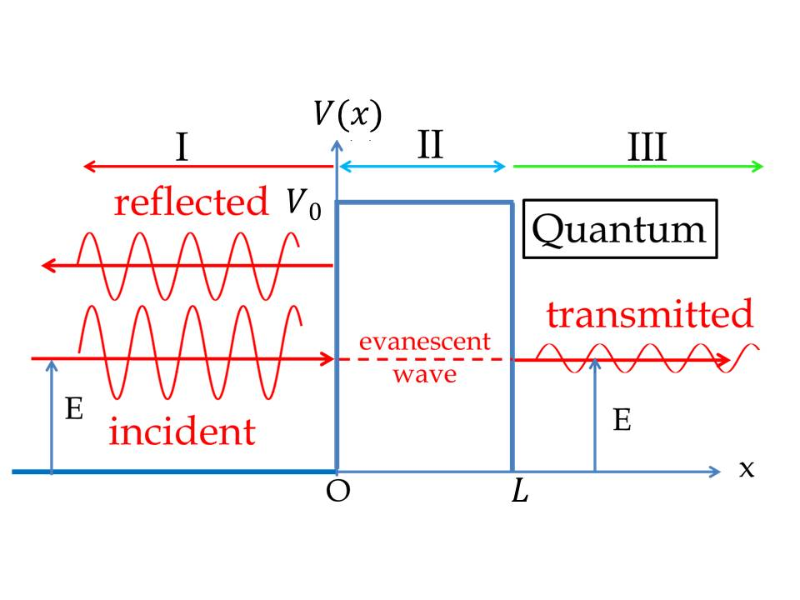

1. :
2. :
3. : Where = 0; 0, and, > L.

In, the potential is zero. A moving wave thus has energy greater than the potential. This is also true in. However, in, the energy of the wave is less than the potential.

Therefore, the Schrödinger equation yields two different differential equations depending on the region:

1. and

The general solutions can be written as linear combinations of oscillatory terms in , and as linear combinations of growing and decaying exponentials in :

Note that plane-waves that travel to the right are of the formand plane-waves that travel to the left are of the form. In this experiment, a particle (plane-wave) enters from the left and will partially transmit and partially reflect. However, no particle enters from the right heading towards the left; therefore, there is no term above in.

The coefficients above are fixed by the continuity of the wave function and its derivative at each point where the potential changes. One obtains two conditions from continuity at and



And two conditions from continuity of the derivative at and



Dividing 3) by  and adding to 1) obtains

Similarly, dividing 4) by  and adding or subtracting from 2) obtains

Combining 5), 6), and 7) yields an equation for  in terms of :

Which can be rearranged to,

Now the probability of a wave to tunnel through the barrier is equal to the probability of the wave function in  divided by the probability of the wave function in . Multiplying the above equation by its conjugate and taking the inverse, the probability of transmission is therefore quantified by

Since

Defining makes the solution more compact

This can also be rewritten in terms of the energies:

Naturally, the probability of reflection is; hence,

Macroscopically, objects colliding against a wall will be deflected. This is analogous to the reflection probability being and transmission probability being. The above example shows that it is possible for matter waves to "go through walls" with some probability, given that a matter wave has sufficient energy or the barrier being sufficiently narrow ((small L).

Note that, for a very wide or tall barrier (L very large)) or, the  term in the expression for  goes to, yielding  for a very wide or tall barrier, there is almost no transmission.